Hierlihy Churchyard

This is the churchyard and cemetery for the Town Point settlement. It is marked on the Admiralty map of 1847 as “Eng. Church.”

Here is the stone of Timothy Hierlihy (died 1830(?) at 76 years of age) and Lucy (?).
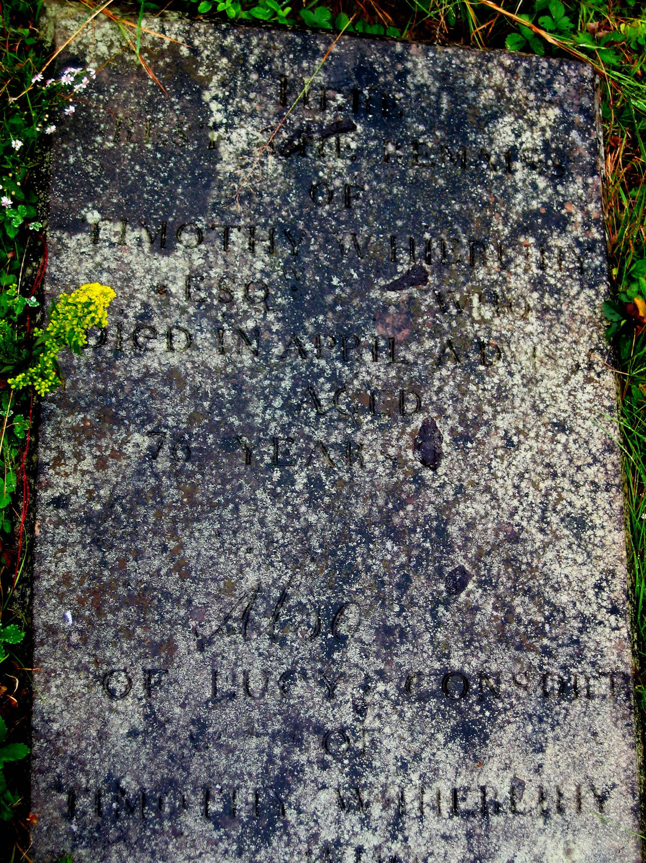

Lucy’s half of the stone, indicating that she died in 1838(?) at age 73. “Be ye also ready.”
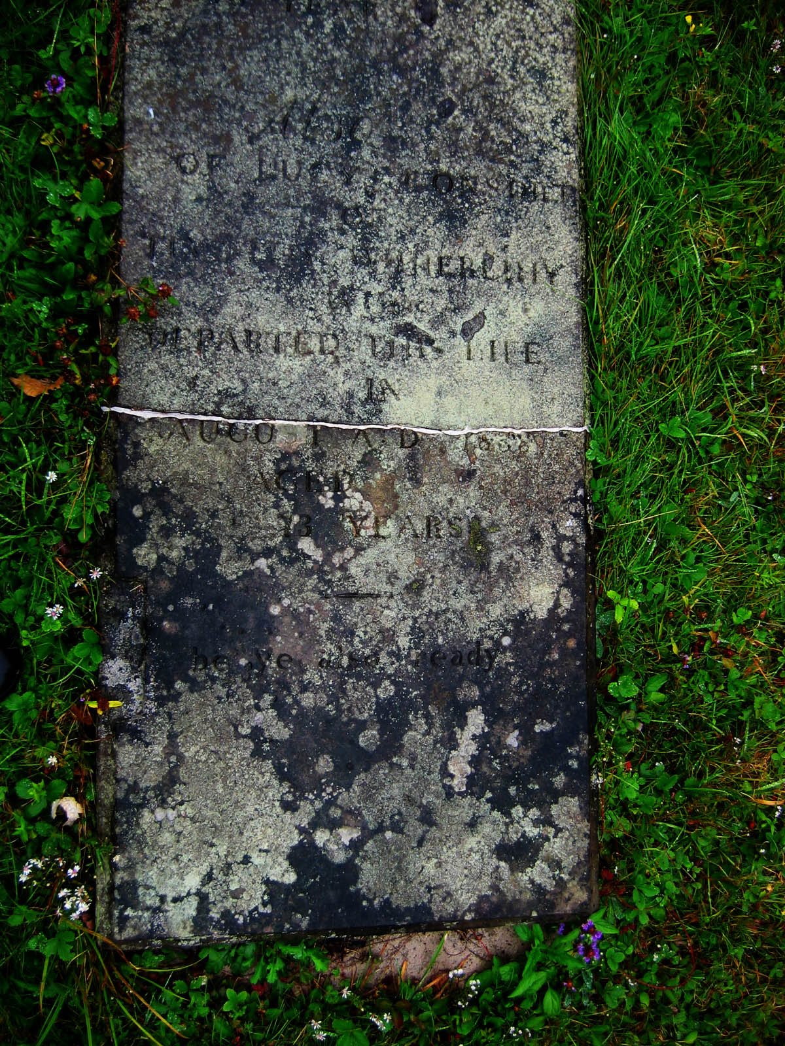

Stone of Margaret Hierlihy who died in 1829.
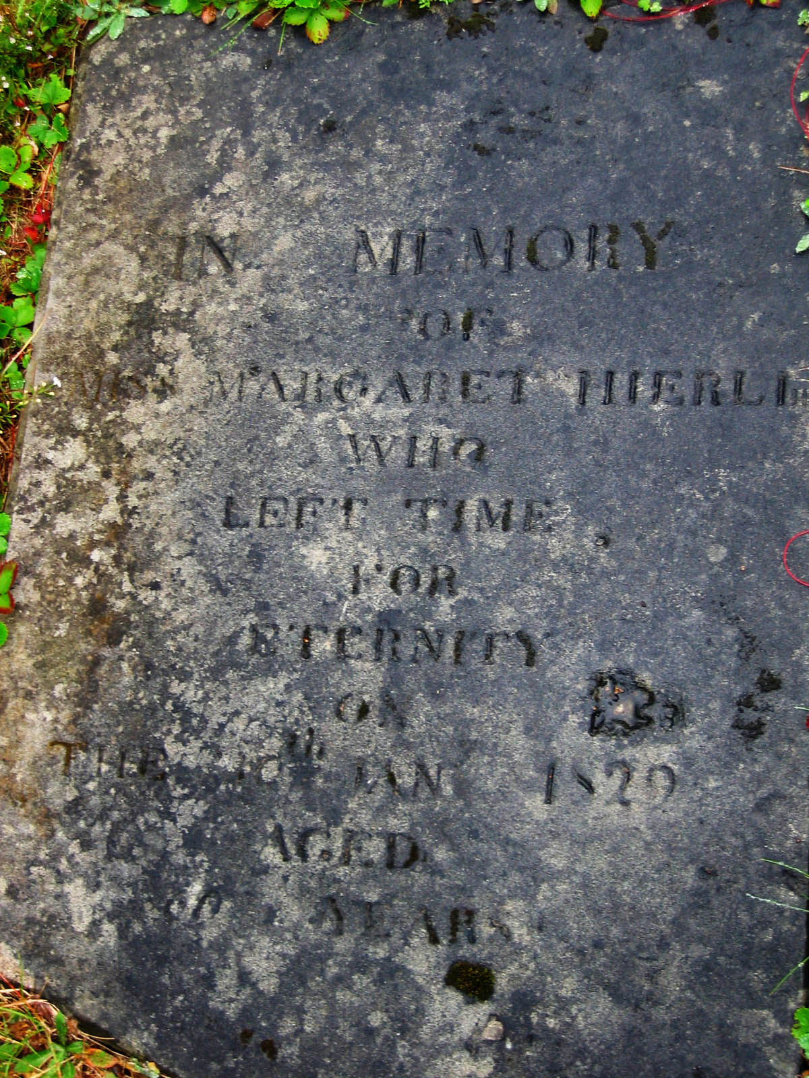

Detail of Benjamin Ogden’s headstone. He died in 1835 age 70.


