Livingstone-Brown (Livingstone_CoveBLDW60_4191.doc)

This house site south of the main road near Livingstone’s Cove was probably built by a Livingstone and later, perhaps around 1900, occupied by a Brown from Greendale. Bernie thinks the house was old, maybe built around 1801. His evidence is the use of round boulders in construction, since later settlers would have had the time and resources to collect better stone. (However, on Eigg Mountain early settlers built log houses with cellars that used no stone.)

He describes how most of the Livingstone’s had left by the 1930s(?) and remembers talking to one who went to New Glasgow who only regretted that he hadn’t left 20 years earlier.

There was an unidentified steel structure rusting in the cellar.
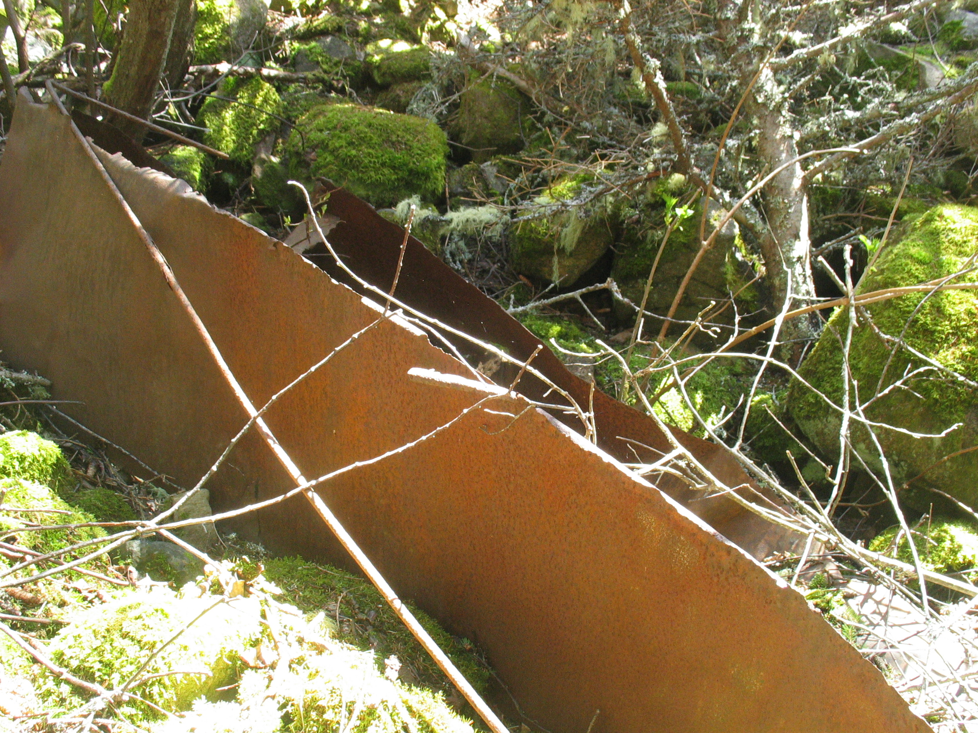
The following photo gives a better indication of the round boulder that Bernie was referring to.
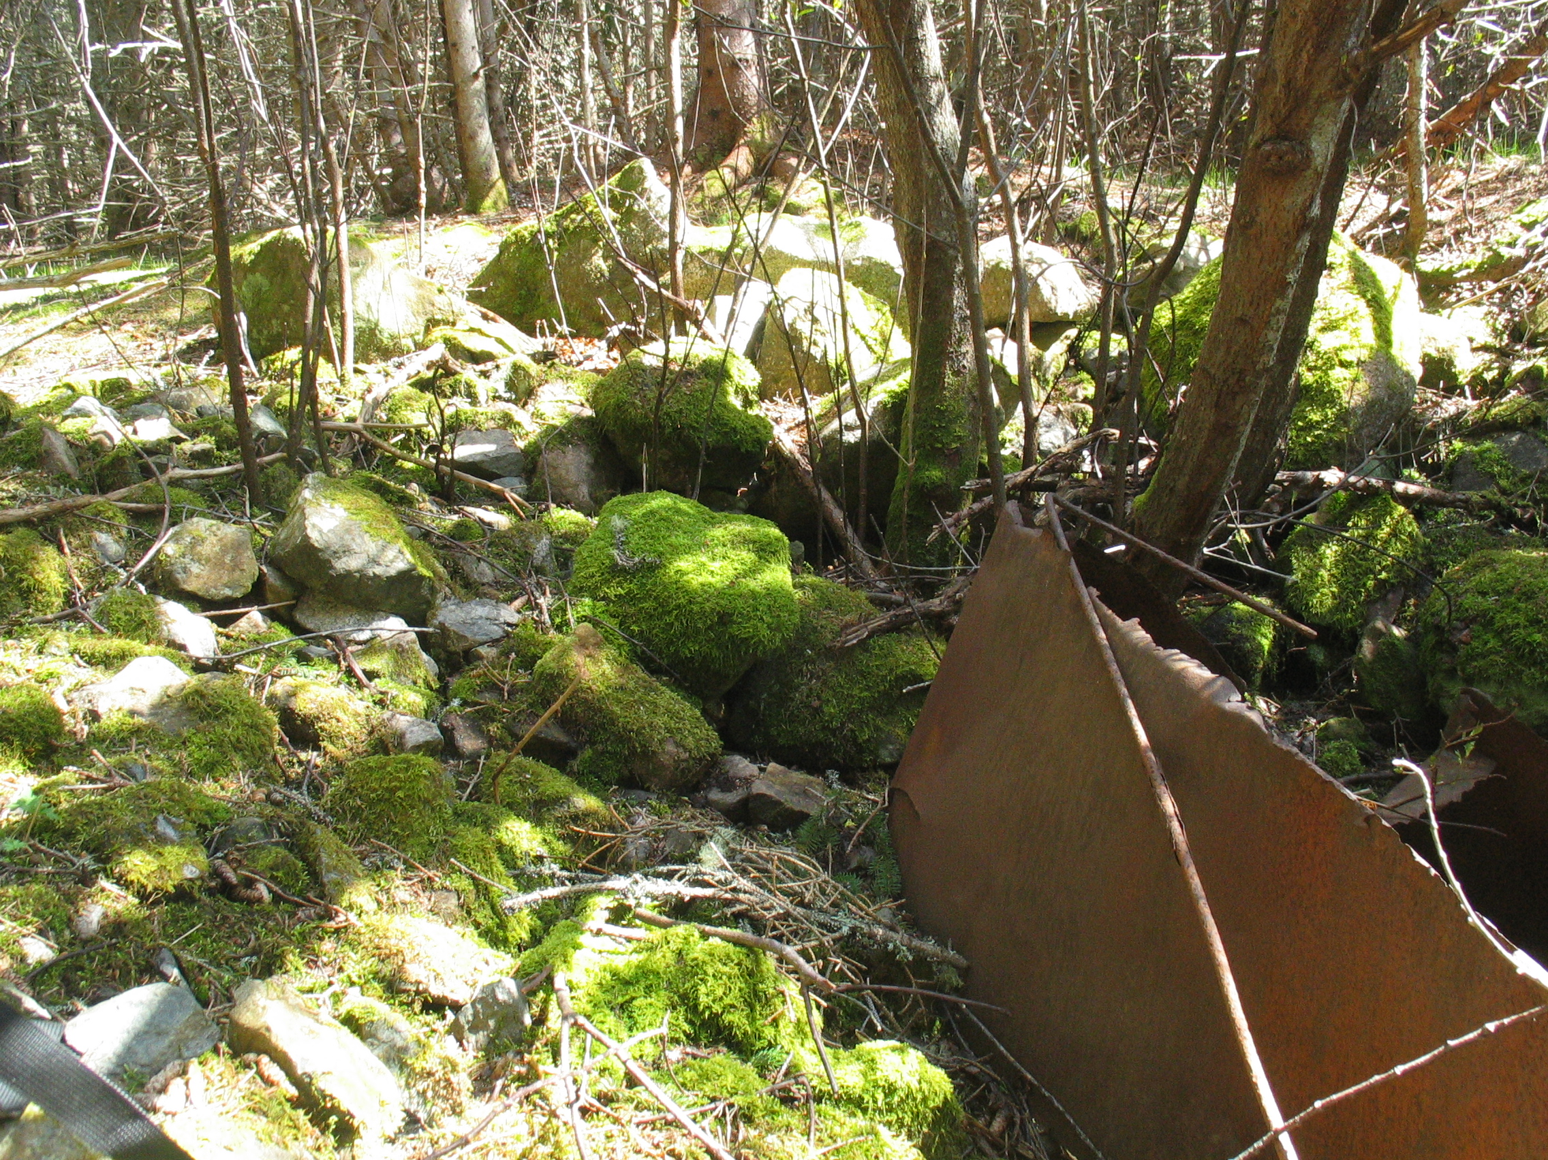

Livingstone’s cove, May 20. 2008.

