Here is an example of the idea that the water, in this case Pomquet Harbour, is a sewer.

This site, meters from the house, appears to have been used as a dump for generations.

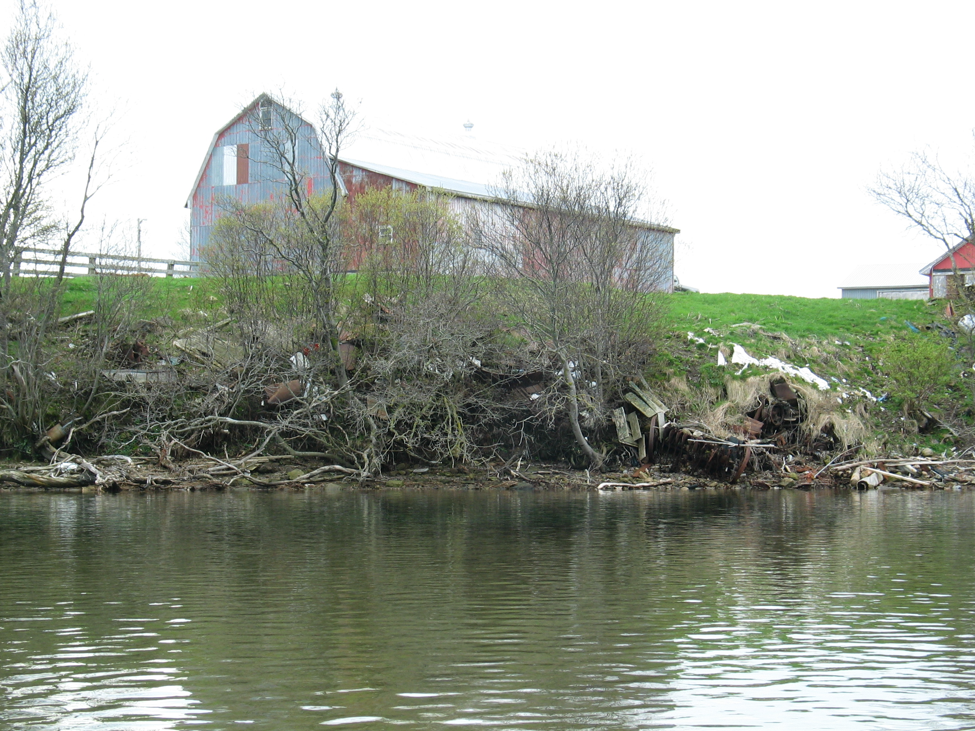

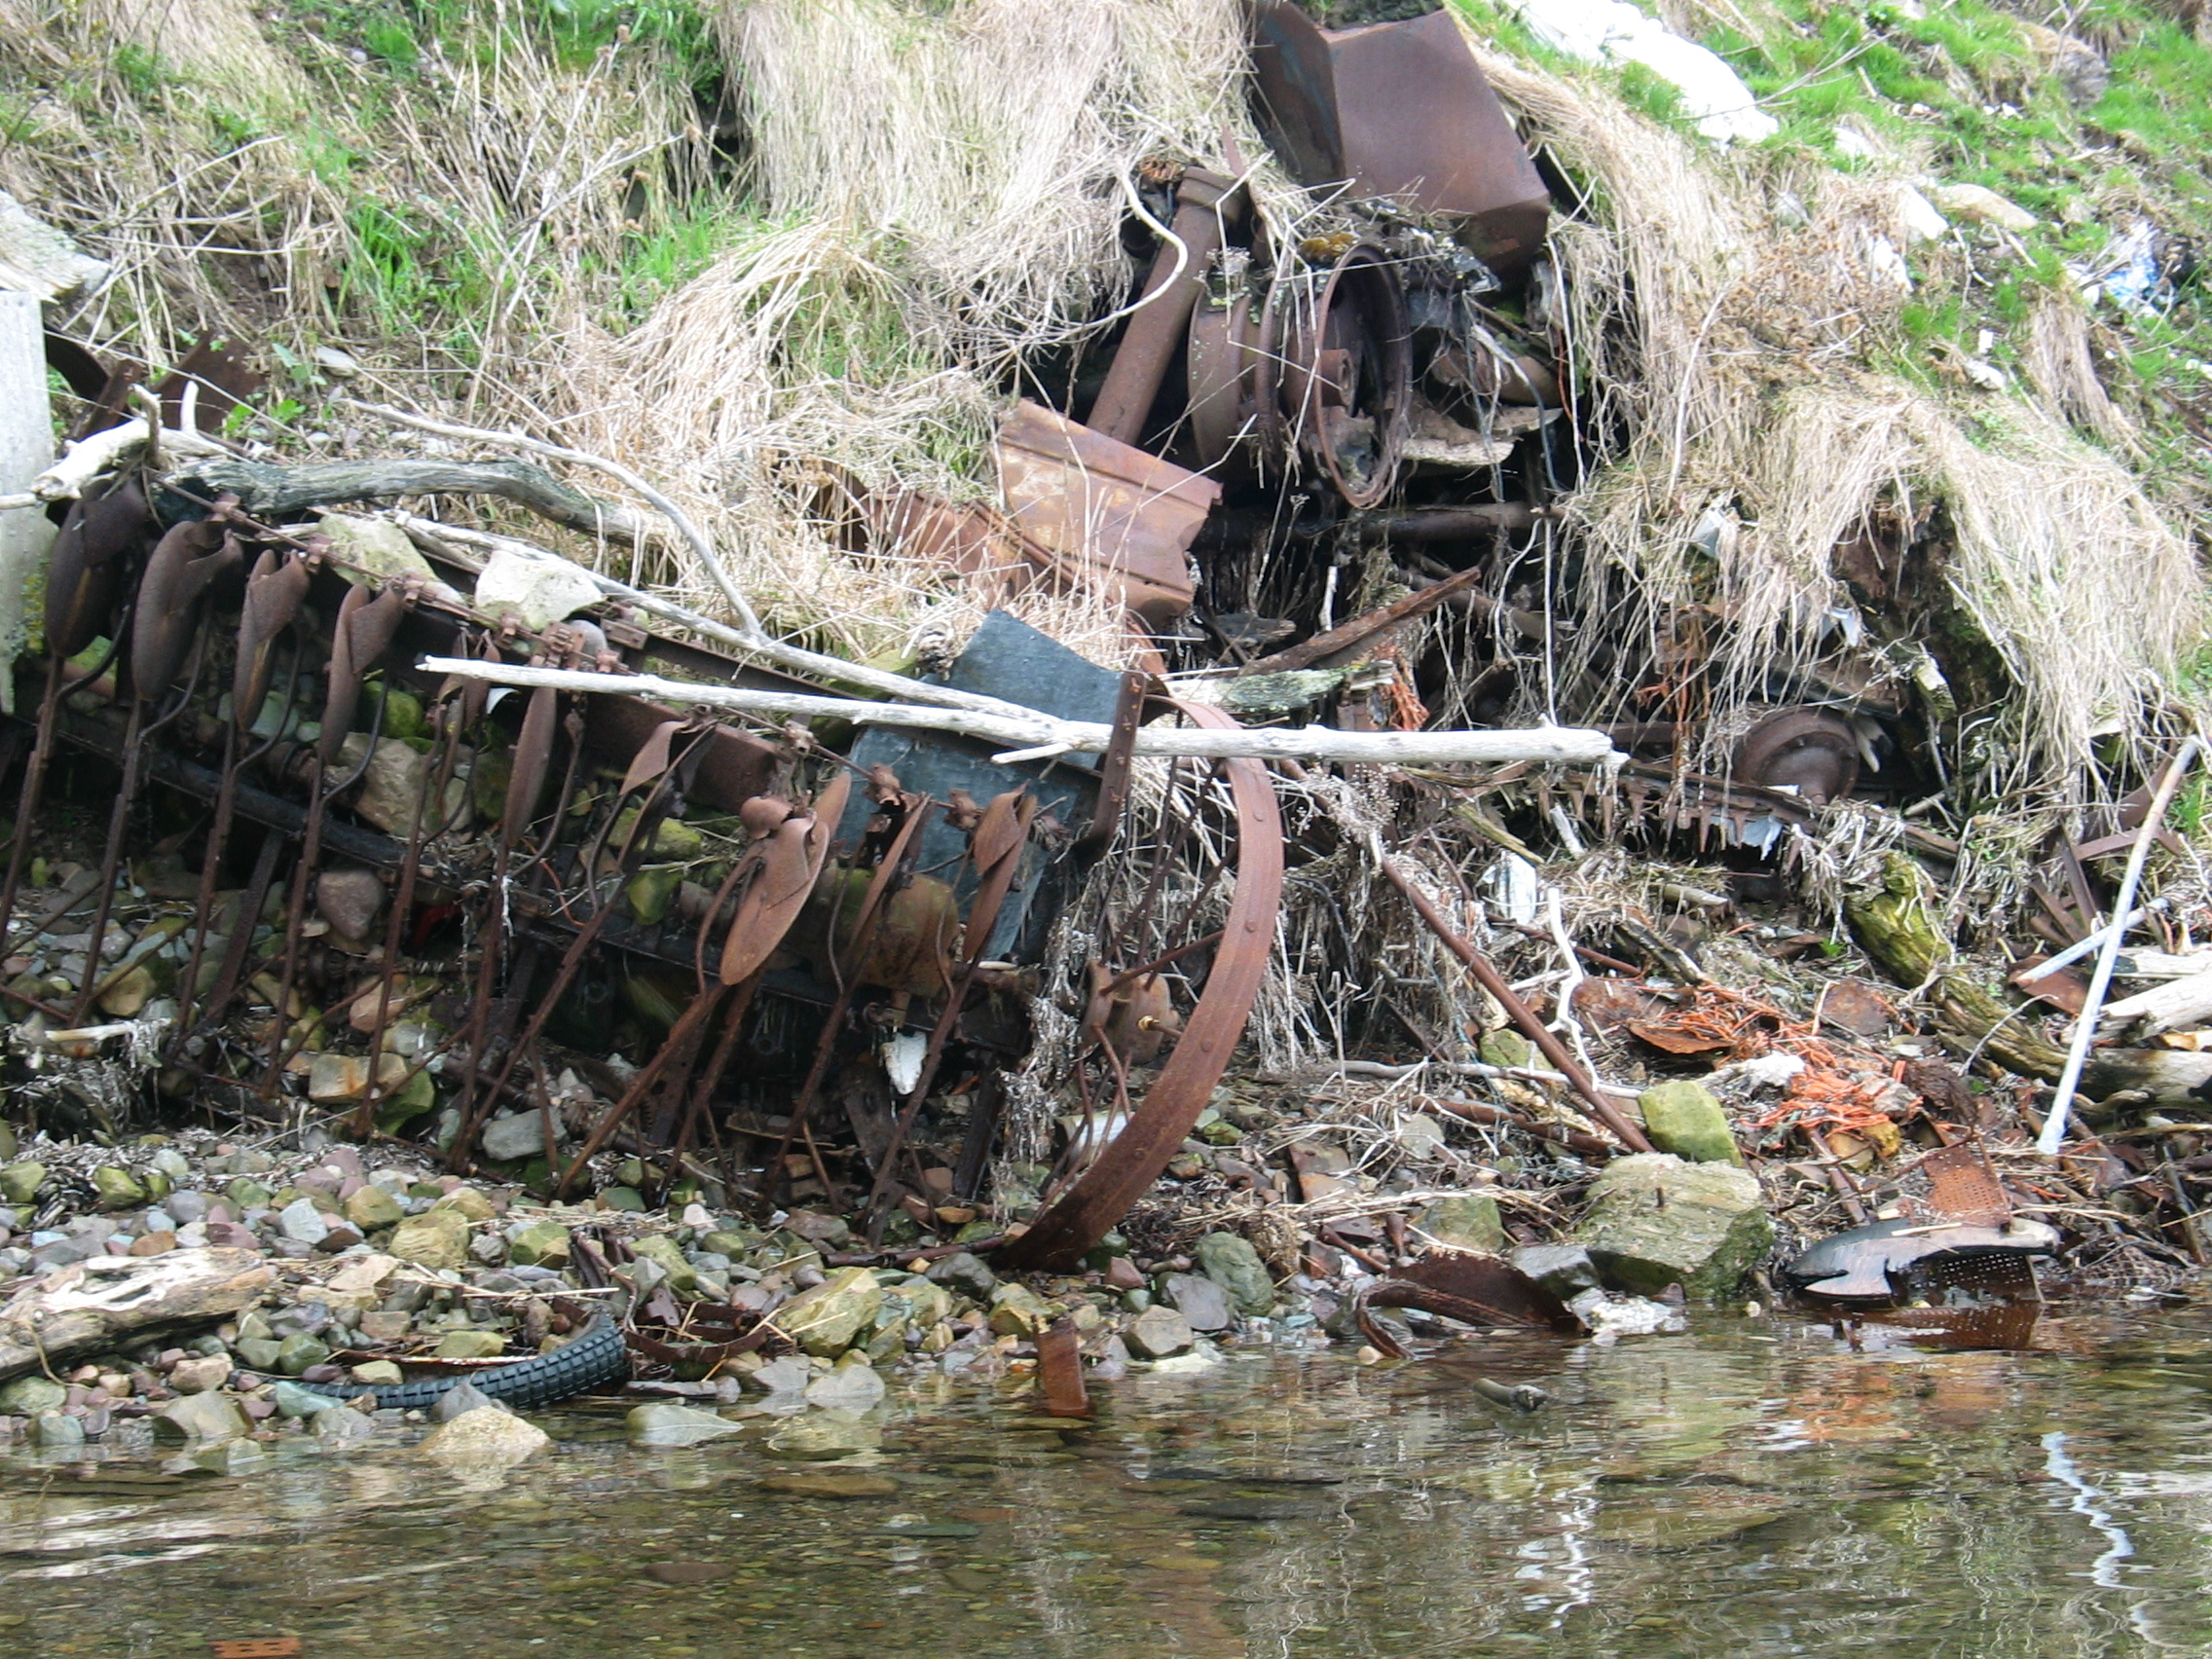

May 7, 2007

