Did you get this in your mailbox?

I left it with you because I see that you feed the birds; I may have tried your door and got no answer, or I may have just been cruising by with only enough time to drop this off.

Basically, and there’s more info on the next pages, we’re doing a survey of wild birds on Sunday, Dec. 17th, 2023. If you’d like to help out by keeping track of what you see in your yard, great! You’ll be joining about 15 other homes doing the same thing.

I hope to meet you in person some time!

Randy

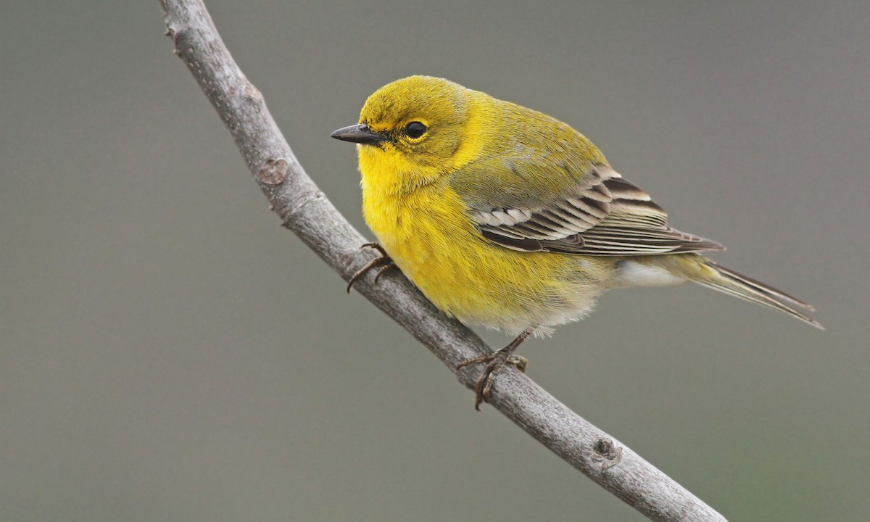
This is a Pine Warbler in winter plumage. It can be at your feeder, and you may never know it, as it looks a lot like a goldfinch. Note the yellow arc around its neck and the thinner bill. We often get one or two of these sneakers on the Antigonish Christmas Bird Count each year.

Name _______________ Phone ______________
email ______________
2023 Antigonish Christmas Bird Count

Hi! You’re getting this because I know, or think, you’re interested in birds. If you want to help out with this survey, great! We’ve been doing it for some 50 years in Antigonish, over a hundred years across North America. For more info about our count, and links to more information, see: http://people.stfx.ca/rlauff/personel/AntigonishCBC/AntCBC.html. There are downloadable forms which you can use, or you can just pass this paper back to me.
Listed below are the species most often found at feeders in our area at this time. You can count all the wild birds (no chickens please!) in and around your yard (on the 17th of December) in the following manner: for most species, record the maximum number you see at any one time. For instance, the chickadees that visit your feeder often come in flocks. Each house usually has one resident flock which comes to feed throughout the day. If at first you see four chickadees, and later on you see five and then three, the number you would record would be five (not 12). The exception to this "maximum number" rule is if you can tell the difference between males and females (e.g. woodpeckers). If you get one male downy woodpecker, then later you get a female, you could record 2 Downy Woodpeckers.
If you saw a species on the 14th, 15th, or 16th of December 2023, but not on Count Day, (the 19th), you can mark the space next to the bird with a "CW" (count week); there is no need to supply numbers. Also, in the next three days (18th 21st), if you see a species that you suspect was not found on Count Day, please phone (867-2471) or email me at randy.lauff@gmail.com and I will update the list.
If you are away from your yard and wish to report birds you see, please record them below (I have to report “birds in the field” differently from “birds at the feeders”). I’ll be glad to come out and try to identify any problem birds you may have or you can send me some photos to the email address above.
Good Birding,
Randy

Birds away from your yard

Location _________________

Amount of time __________ Distance covered ___________

Birds seen (and numbers)
In the following list, I have put this icon to denote problem birds – either birds that are uncommon (at least at this time of year), or that have posed some identification challenges before. Be careful with these. And please don’t fear if I ask, “What made you think that bird was a …?”. If I don’t get details from you, the sponsoring organizations will not accept the sighting. So, humour me, tolerate me, but please don’t get suspicious, mean, or violent if I ask for a few details…thanks!

Sharp-shinned Hawk
Merlin
Ruffed Grouse
Rock Pigeon (Pigeon)
Mourning Dove
Downy Woodpecker
Hairy Woodpecker
Pileated Woodpecker
Blue Jay
American Crow
Black-capped Chickadee
Boreal Chickadee
Red-breasted Nuthatch
White-breasted Nuthatch see note:
American Robin
Bohemian Waxwing
European Starling
American Tree Sparrow
Song Sparrow
White-throated Sparrow
Dark-eyed Junco
Snow Bunting
Red-winged Blackbird
Brown-headed Cowbird
Purple Finch
House Finch
Common Redpoll
Pine Siskin
American Goldfinch
Evening Grosbeak
House Sparrow
Others

White-breasted Nuthatch: Please note that this species is a lot larger than the Red-breasted. It does not have a stripe through the eye. Female Red-breasteds are paler than males and can be mistaken for White-breasteds.

Roughly how much time did you spend
watching your feeder? This does not mean how much time you spent staring at your feeder, rather the time span in which you, at least periodically, checked on the birds in your yard.

Do you wish to be contacted next year about participating again?

Yes ____ No thanks ____

Do you know of anyone else with a feeder who would like to participate? If so, please write down their name and number/email and if you wish, alert them that I will contact them.

