RefWorks Exercise
HK 396 Quantitative Research Methods

RefWorks -- an online research management, writing and collaboration tool -- is designed to help researchers easily gather, manage, store and share all types of information, as well as generate citations and bibliographies.

- Create a RefWorks account by following the link and subsequent instruction from the StFX Library web site (https://www.mystfx.ca/library/refworks ).

- Within your RefWorks account create a new folder called HK396TEST.
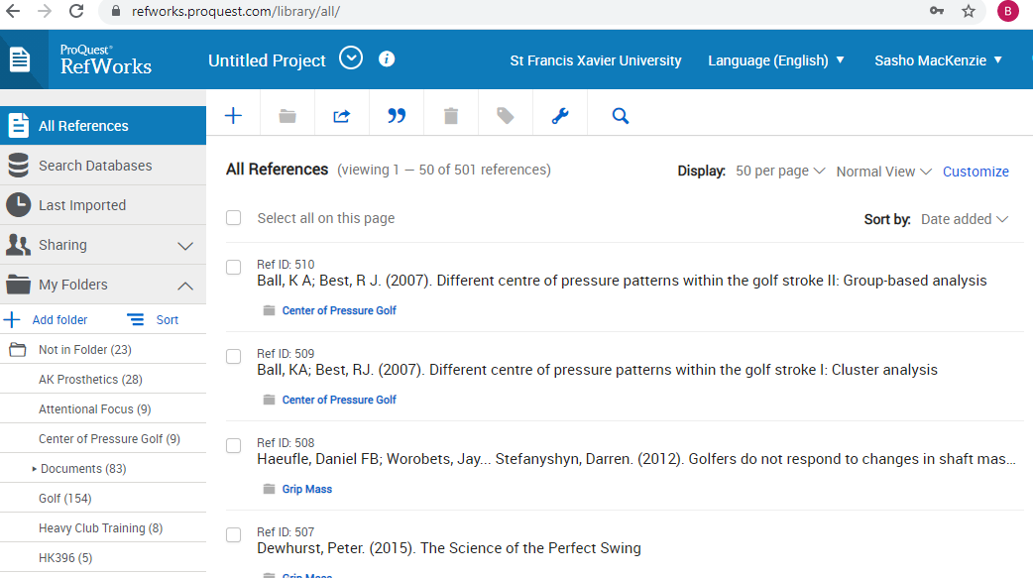

- With your RefWorks account open, go to google scholar from a separate window or tab (http://scholar.google.ca/) and search for the following article:
  - “A biomechanical comparison of the vertical jump, power clean, and jump squat”

- Change your Settings in Google Scholar to allow automatic importing of citations into RefWorks. While in Google Scholar click the drop down menu and then click Settings.

Or

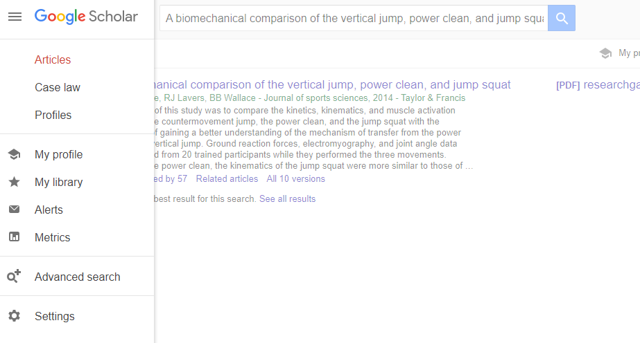

- At the bottom of the settings page select “Show links to import citations into RefWorks” and save your settings.

- Once back on the Google Scholar search page, you will notice “Import into RefWorks” under the first search item. Click this to initiate the automatic import into Refworks.

- Following the instructions to import into the newest version of RefWorks.
- Put the reference in the HK396TEST folder. Do this by clicking the check box associated with the reference and selecting HK396TEST from the folder drop down. 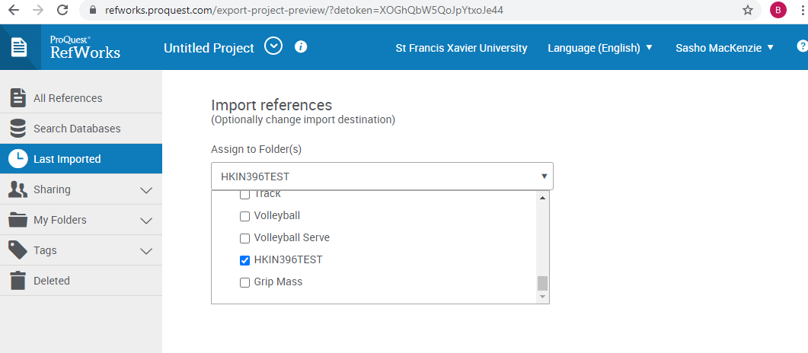

- Search for the following three articles using Google Scholar and put them in the HK396TEST folder as well.
  - Harman, E.A., Rosenstein, M.T., Frykman, P.N., & Rosenstein, R.M. (1990). The effects of arms and countermovement on vertical jumping. Med Sci Sports Exerc, 22, 825-833.
  - Baker, D. (1996). Improving vertical jump performance through general, special, and specific strength training: A brief review. The Journal of Strength & Conditioning Research, 10, 131-136.
  - Sale, D., & MacDougall, D. (1981). Specificity in strength training: a review for the coach and athlete. Canadian Journal of Applied Sport Sciences, 6, 87-92.

- Open Microsoft Word and Add RefWorks Citation Manager to the Menu Bar
  - From the Insert menu, click on Get Add in. Search for “Refworks” and click “Add”
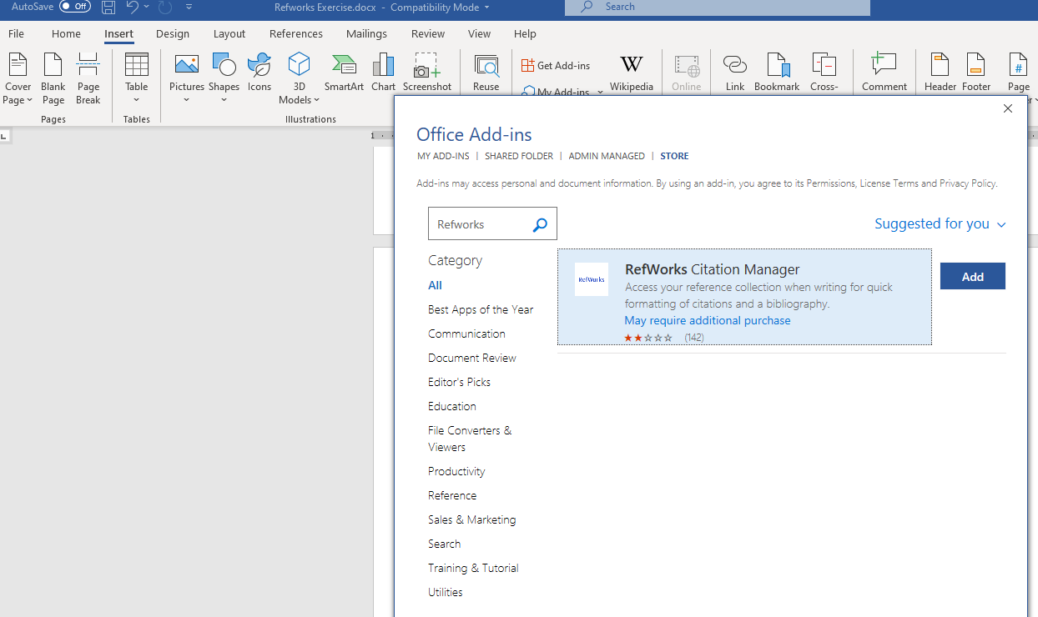

Refworks (RCM)…should now appear in menu

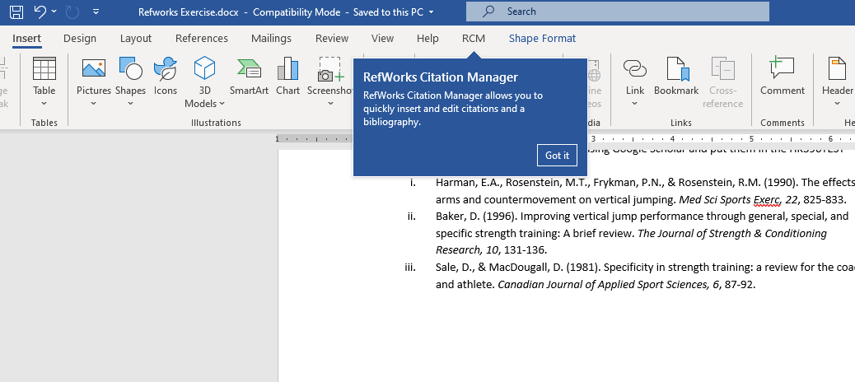

- Copy and Paste the following paragraph into a new Word document and SAVE IT IN A HK396 FOLDER YOU CAN FIND LATER with the name “HK396 RefWorks Exercise.
The vertical jump is an explosive movement important in many sports (Harman, Rosenstein, Frykman, & Rosenstein, 1990). A review by Baker (1996) suggests that both general strength training (e.g. squats) and specific strength training (e.g. depth jumps) can play key roles in a program designed to improve the vertical jump. However, special strength exercises, such as jump squats and Olympic-style lifts, are probably the most effective (Baker, 1996). In general, it is believed that a training exercise should follow the principle of specificity: the exercise should be similar to the targeted sport movement with regard to the kinetics, kinematics, and contraction type (Sale & MacDougall, 1981). Further, in order for a training exercise to facilitate an improvement in performance in a sport movement, such as vertical jumping, the exercise must stimulate a trainable feature of the neuromuscular system beyond the level that can be achieved when executing the sport movement.
- In place of the blue text, you are going to use the RefWorks add-in in Word to insert a citation and create a bibliography.
- Click “RCM” from the main Menu bar in Word.
- Click on Refworks Citation Manager to open it in the side bar. Log in.
- Change the style to APA 6th.
- Search for the “Harman” reference first.
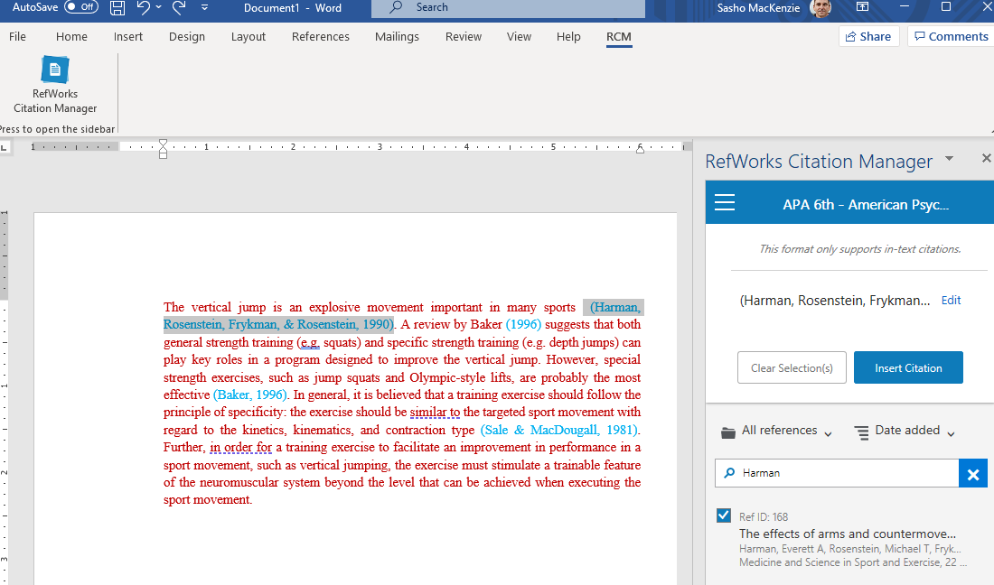
- With your cursor at the start of the blue text (Harman, Rosenstein, ….) , select the check box for the Harman reference and click Insert Citation. After it is inserted, delete the blue text. Repeat for the Sale and MacDougall reference.
- For Baker (1996), you need to “hide the author” since the author name is mentioned in the text. After searching and checking the citation, click on “edit” next to the citation shown in the side bar. Then uncheck the “include author” option.
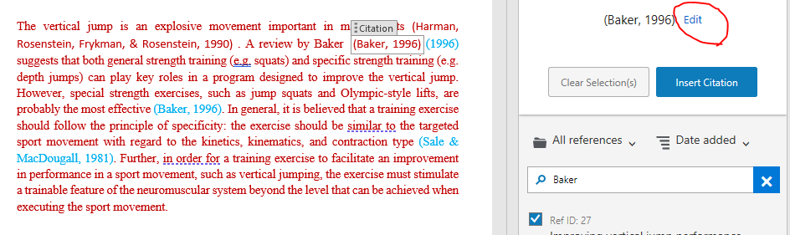
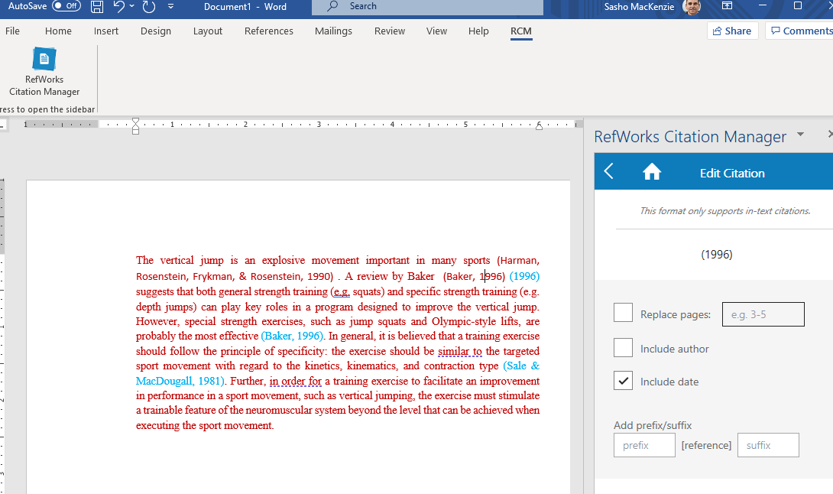

- From the RefWorks menu in the side panel, turn the “Bibliography” option on, and the References will automatically be entered into the Word document in the correct style.
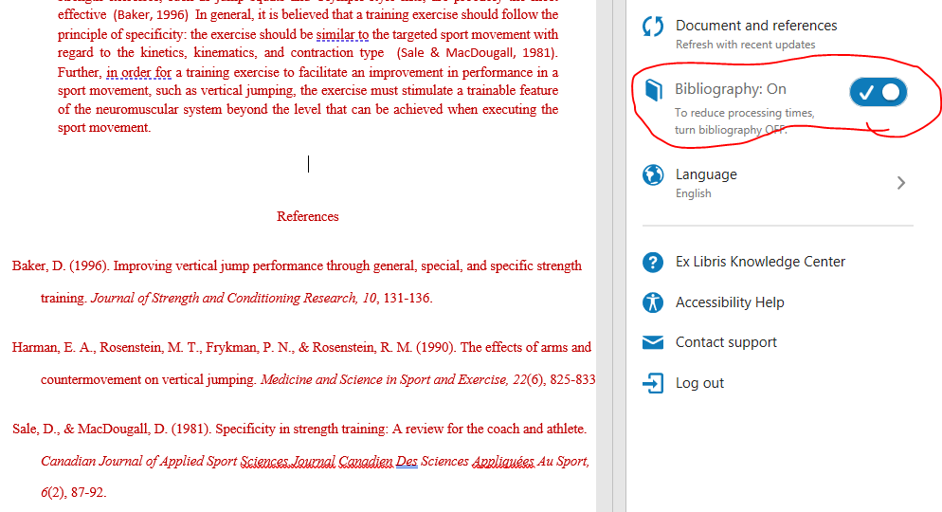

- Please use Refworks on a regular basis for organizing the articles you find for your Hypothetical Study.

