Multiple Regression Exercise

Multiple regression is used to assess the relationship between one dependent variable and several independent variables. Often the goal is to use the independent variables to predict the dependent variable. For this reason, the independent variables are called predictors and the dependent variable is referred to as the criterion. Maybe a researcher is interested in determining the most important factors (e.g., driving distance, greens in regulation) for winning on the PGA Tour. Perhaps the criterion is difficult to routinely measure and the research wants to develop a prediction equation based on more easily measured variables; for example, a researcher might want to estimate percent body fat based on skinfold thickness from several anatomical locations.
In this exercise, you will work from a contrived example in which there is an exact linear equation which allows the criterion variable to be explicitly determined from the predictors.

In high jumping, the height an athlete clears (Bar Height) may be regarded as the sum of three separate heights (Hay, 1993):
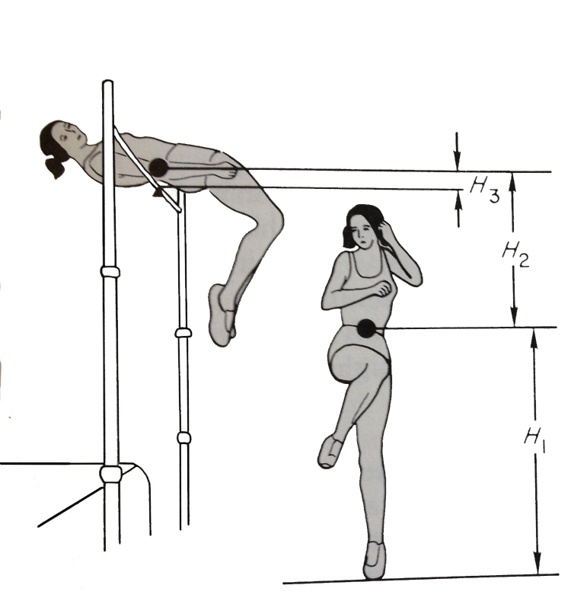
H1: Takeoff Height – the height of the athlete’s center of gravity at the instant of takeoff.

H2: Flight Height – the max height that the athlete raises the center of gravity during the flight.

H3: Clearance Height – the difference between the maximum height reached by the center of gravity and the height of the crossbar.

For the purpose of this exercise H1 will be measured in feet, H2 in meters, and H3 in inches. Therefore, the following equation gives Bar Height in centimeters:

Bar Height (cm) = 30.48*H1 + 100*H2 + 2.54*H3

The number in front of each height represents the conversion factor from each unit of measurement into centimeters. The conversion factors will be revealing when interpreting the output from the regression analysis.

Instructions

- Download Multiple Regression Exercise.xlsx from my webpage and save it to your H: drive.

- Copy and Paste the data from the “Data” worksheet into an SPSS .sav document and save it to your H: drive.

- Follow along with the document “How to Perform a Multiple Regression Analysis in SPSS.docx” to determine the relative importance of each sub height in determining Bar Height.

